TEACHER PERCEPTIONS TOWARDS CHROMEBOOK USE IN SCHOOLS IN SOKAN DISTRICT

Abang Julianto, Tanjungpura University, Pontianak, West Kalimantan
Email: abangjulianto@gmail.com
WhatsApp Phone Number Corresponding Author : 082148102141

Abstract: This study aims to analyze the perceptions of elementary and secondary school teachers regarding the use of Chromebooks in learning activities in schools in Sokan District. The background of this research is based on the implementation of an educational digitalization program that encourages the use of technological devices, particularly Chromebooks, as a means to improve the effectiveness and efficiency of the learning process. This study used a descriptive quantitative approach, collecting data through distributing questionnaires to elementary and secondary school teachers. The data obtained were analyzed using descriptive statistics to describe teachers' perceptions regarding ease of use, pedagogical benefits, and obstacles to implementing Chromebooks in the school environment.

The results indicate that the majority of teachers have positive perceptions of Chromebook use, particularly in supporting interactive learning, increasing access to digital learning resources, and strengthening technological literacy among students. However, several obstacles remain, including limited internet access, lack of technical training for teachers, and adaptation to changes in technology-based learning models. Based on these findings, this study recommends the need to improve information and communication technology (ICT) competencies for teachers and strengthen digital infrastructure in schools, so that the use of Chromebooks can run optimally and sustainably in supporting the quality of learning in Sokan District.

Keywords: Teacher perception; Chromebook; Digitalization of education; Technology-based learning; ICT competency.

Introduction
1.1 Background
The development of information and communication technology (ICT) has brought significant changes to the world of education. The Indonesian government, through various policies, has encouraged the use of digital devices in the learning process, one of which is through a program to provide Chromebooks to schools. Chromebooks are devices based on the Chrome OS operating system that connect directly to the Google Workspace for Education ecosystem, supporting cloud-based and collaborative learning.
Sokan District, as an area in Melawi Regency, has begun implementing the use of Chromebooks in schools, both elementary and secondary. However, the success of educational technology implementation is determined not only by the availability of devices but also by teachers' perceptions of their usefulness and ease of use. Positive perceptions will encourage teachers to actively utilize Chromebooks in the teaching and learning process, while negative perceptions can hinder digital learning innovation.
Therefore, this study aims to describe teachers' perceptions of Chromebook use in schools in Sokan District. The analysis was conducted using a quantitative descriptive approach using questionnaires completed by teachers who use Chromebooks.
1.2 Problem Formulation
- What are teachers' perceptions of the ease of use of Chromebooks in schools?
- How do teachers perceive the usefulness of Chromebooks in learning activities?
- What are teachers' attitudes toward changes in learning resulting from the implementation of Chromebooks?
1.3 Research Objectives
- To describe teachers' perceptions of the ease of use of Chromebooks.
- To describe teachers' perceptions of the usefulness of Chromebooks.
- To describe teachers' attitudes toward changes in learning resulting from the use of Chromebooks.
1.4 Research Benefits
This research is expected to be beneficial:
- Theoretically, it adds to the literature on the adoption of educational technology in schools.
- Practically, it serves as evaluation material for schools and education offices to improve the effectiveness of Chromebook use.

Methods
2.1 Type of Research
In this study, I used a quantitative descriptive approach with the aim of providing an empirical overview of teachers' perceptions of Chromebook use in Sokan District. This approach was chosen because it is considered capable of objectively describing phenomena through measurable data that can be analyzed statistically.
2.2 Population and Sample
The research population consisted of all teachers who have used Chromebooks in schools in Sokan District. The research sample was selected purposely, namely teachers who actively use Chromebooks in teaching and learning activities. The total number of respondents was 50 teachers.
2.3 Research Instrument
The research instrument was a closed-ended questionnaire with a 5-point Likert scale:
1 = Strongly Disagree (STS)
2 = Disagree (TS)
3 = Neutral (N)
4 = Agree (S)
5 = Strongly Agree (SS)

The questionnaire covered three dimensions:
Perceived ease of use (3 items)
Perceived usefulness (3 items)
Attitude toward change (2 items)
Behavioral intentions (2 items)
2.4 Data Analysis Technique
Data were analyzed descriptively quantitatively using percentage analysis. Percentages were calculated for each response category using the formula:
$P=\frac{f}{N}x 100\%$
Where P is the percentage, f is the frequency of responses, and N is the number of

Results And Discussion

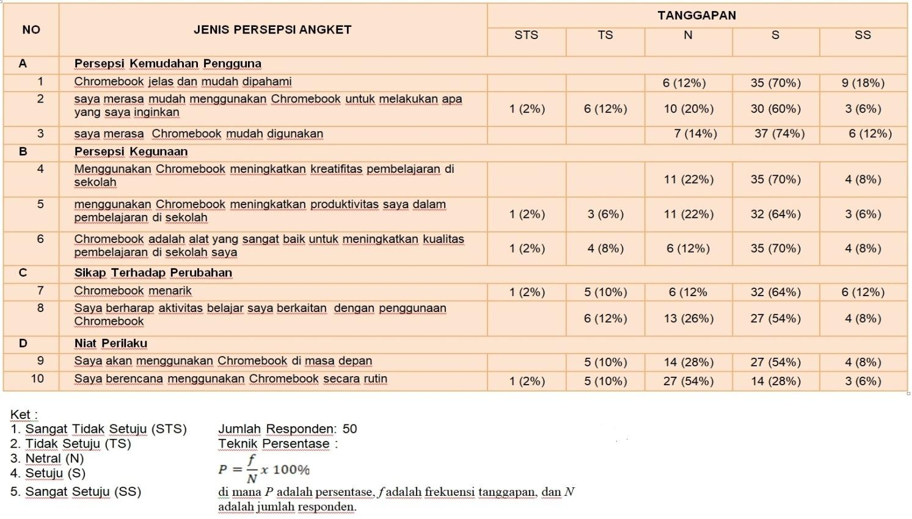
3.1 Description of Questionnaire Results
The analysis results show that the majority of respondents responded positively to the use of Chromebooks. The following is a summary of the results per dimension:
- Perceived Ease of Use
Items 1–3 relate to the ease of understanding and using Chromebooks.
Findings:
The dominant responses were Agree (S) and Neutral (N).
For item 3, the Agree score was very high (37 respondents), indicating that
Chromebooks are perceived as easy to use.

- Perceived Usefulness
Items 4–6 assess the benefits of Chromebooks on creativity, productivity, and
learning quality.
Findings:
Most respondents chose Neutral (N) and Agree (S).
Items 5 and 6 had a high level of "Agree" (32 and 35 respondents,
respectively).

- Attitudes Toward Change
Items 7–8 evaluated attitudes toward the integration of Chromebooks into learning.
Findings:
The response "Agree" was dominant, especially for item 7 (32 respondents).
Respondents generally accepted changes in technology use.

- Behavioral Intention
Items 9–10 assessed interest in using Chromebooks in the future.
Findings:
The majority selected Agree, indicating a strong intention to continue using Chromebooks.

3.2 Discussion
The results of this study reinforce the TAM theory (Davis, 1989), where perceptions of ease of use and usefulness influence attitudes toward technology acceptance. Teachers in Sokan District demonstrated a high level of acceptance of Chromebooks due to their ease of operation and immediate benefits.

However, several technical constraints remain, such as limited internet connection, power availability, and the need for further training. Therefore, ongoing training on Chromebook use is necessary to optimize their use.

Conclusion
4.1 Conclusions
- Most teachers found Chromebooks easy to understand and use.
- Chromebooks were considered beneficial for improving the learning process, productivity, and quality of instruction.
- Teachers had positive attitudes toward technological changes brought about by Chromebooks.
- Teachers had a strong intention to continue using Chromebooks in their learning activities.
Overall, teacher acceptance of Chromebooks was highly positive, indicating that the school digitalization program through Chromebooks in Sokan District is running well.

4.2 Recommendations
- Local governments and schools need to provide ongoing training on Chromebook use and integration with digital learning platforms.
- Internet access and supporting infrastructure need to be improved to optimize Chromebook use.
- Further research is recommended to explore the factors influencing technology acceptance among teachers.

References
Davis, F. D. (1989). Perceived usefulness, perceived ease of use, and user
acceptance of information technology. MIS Quarterly, 13(3), 319–340.

Kemendikbud. (2023). Panduan pemanfaatan Chromebook untuk pembelajaran
digital di sekolah. Direktorat Sekolah Menengah.
Surjono, H. D. (2021). Pembelajaran digital berbasis cloud computing. UNY Press.
Walgito, B. (2017). Psikologi sosial (suatu pengantar). Andi.

